Process Control Block (PCB)
A Process Control Block is a data structure maintained by the Operating System for every process. The PCB is identified by an integer process ID (PID). A PCB keeps all the information needed to keep track of a process as listed below.

Information & Description:
Process State
The current state of the process i.e., whether it is ready, running, waiting, or whatever.
Process privileges
This is required to allow/disallow access to system resources.
Process ID
Unique identification for each of the process in the operating system.
Pointer
A pointer to parent process.
Program Counter
Program Counter is a pointer to the address of the next instruction to be executed for this process.
CPU registers
Various CPU registers where process need to be stored for execution for running state.
CPU Scheduling Information
Process priority and other scheduling information which is required to schedule the process.
Memory management information
This includes the information of page table, memory limits, Segment table depending on memory used by the operating system.
Accounting information
This includes the amount of CPU used for process execution, time limits, execution ID etc.
IO status information
This includes a list of I/O devices allocated to the process.

The architecture of a PCB is completely dependent on Operating System and may contain different information in different operating systems.

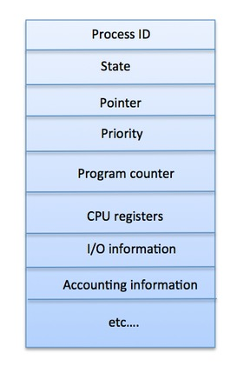
Figure – A simplified diagram of a PCB

The PCB is maintained for a process throughout its lifetime, and is deleted once the process terminates.

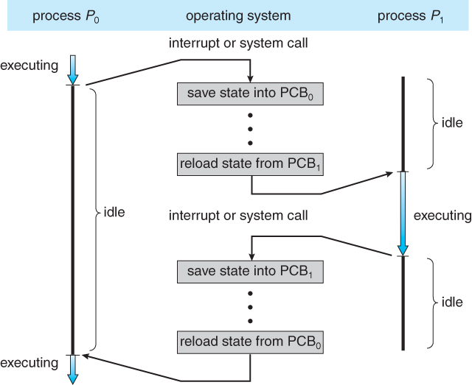

Figure - Diagram showing CPU switch from process to process.

Text Books:

1.Abraham Silberschatz, Peter B. Galvin, Greg Gagne, ―Operating System Principles‖, Wiley Student Edition, 8th Edition, 2010.
2.William Stallings, ―Operating System- Internals and Design Principles‖, Pearson Education, 6th Edition, 2002.

Reference Books:

1. Andrew S Tanenbaum, ―Modern Operating Systems‖, PHI, 3rd Edition, 2007.
2. D. M. Dhamdhere, ―Operating Systems a Concept based Approach‖, Tata McGraw-Hill, 2nd Edition, 2006.

